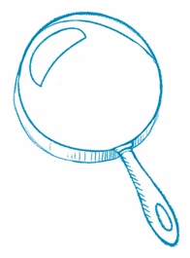
Read Between the Lines
Make an Inference When you make an inference, you go beyond
the author’s words to understand what is not directly said in the text.
Article Title
Inference
What is an idea you gathered from the article that is not directly
stated in the text?
Text Evidence
Which sentences or details support your thinking?

