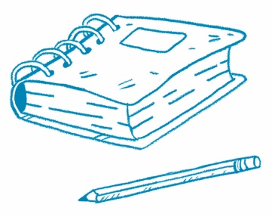
Make a Claim
Author’s Purpose Why do you think the author wrote this article? Use evidence from the text to determine the author’s purpose. To find evidence, look for facts, data, quotes, descriptions, photos, and examples.
Article Title
Make a claim. Why did the author write this article?

Evidence | Evidence
Why do you think the author chose the photo shown in the article?

State your reasoning. How does the evidence support your claim?

