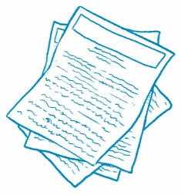
Compare Two Articles
Compare Text Find two news articles about similar topics.
Read each article. Then, answer the questions.
Article Title | Article Title
What is the main idea? | What is the main idea?
What are the key details? | What are the key details?
How are these articles similar?

In what ways are they different?

Which article did you like better? Why?

